INVENTION DISCLOSURE FORM

Instructions:
This form is provided to help you organize your thoughts about your invention. There's nothing "magic" about it. Do whatever you need to do in order to explain your invention in such a way as to be clear to one who is not familiar with it.
- Be careful to describe what, specifically, makes your invention different from what has gone before. Avoid general statements that your invention is "better" – please specify why is it better, or what makes it better?
- If you use any unusual terms, or ordinary terms in an unusual way, explain them.
- In addition to describing all the parts, describe how the parts work together.
- Why did you do things the way you did them, and not some other way? How else could you have accomplished the same end?
- In answering the questions, do not limit yourself to exactly the prototype you have in front of you, or to the very best way you might think your invention might be built. Allow your imagination to run - how else might this invention work? How far would it need to be changed before you say, "that's not my invention any more"? Are there less desirable, but still useful, ways of making the invention work?
- It's as important to point out what is not part of your invention (that is, what is "old") as it is to carefully explain what is new. Has the design, or part of the design, been used before, even if for a different purpose? How else have people accomplished the same function as your invention in the past?
- What are the possible problems? Under what circumstances might your invention not work? Are there critical parts, dimensions, ingredients?
- Drawings are always helpful, and if you are e-mailing this form you can include them electronically in one of the standard graphic formats (PCX, GIF, JPG) or as a drawing file in AutoCAD DXF or DWG formats.
Please note that this document upon completion becomes an official document and you are legally bound by the information you have filled in the form.

1. Please suggest a descriptive title for your invention: (Mandatory)

2. This invention is applicable in which fields: (Optional)

3. Briefly describe your Invention in general terms at basic level: What does it do? How does it do it? (Mandatory)

4. What are the one or more problems that are solved by the Invention: (Mandatory)
(Describe the unmet need/problems in the current solutions and the problem that this invention solves. Throw some light on the existing solutions and their shortcomings.)

5. Describe in detail how your Invention solves the problem with parts and figures: (Mandatory)
(Describe each component of your invention (process or device or product). How do the components work together or process flow of steps to make the invention work? Please explain using figures/flow chart/block diagrams showing all the components of your invention. Also explain in detail the new or novel or unique aspects of your invention.)

6. What are the advantages of your invention over the prior solutions? (Mandatory)

7. Do you know of any competitor product or document, which is similar to your invention? (Optional)
(Please provide link, if any)

8. When was your solution first conceptually or mentally complete? (Optional)

9. What is the first tangible evidence of such completion? (Optional)

10. Has the invention been published or disclosed to any client, vendor, partner etc? (Optional)

Yes No
· If yes, when?
· If planned - when? (Catalog, advertising, data book, application note, conference paper, magazine article, proposal document.)
· Was there a nondisclosure agreement (NDA)?

11. Please list down a few application areas in which this invention can be used? (Optional)

12. Field and Nature of Invention: (Optional)
a. Technical Field / Technology Area (Established / Evolving / New):
b. Nature of Invention / Improvement (Incremental / Substantial / Radical):
c. Valid Life of this Technology (1-3 years, 3-5 years 5+ years):

13. Please provide mandatory ratings on different aspects of this idea (5 being highest):
a. Novelty rating of this idea (1-3-5):
b. Inventiveness rating of this idea (1-3-5):
c. Utility rating of the idea (1-3-5):
d. Number of Unique Features / Embodiments:

Answers

- Please suggest a descriptive title for your invention:
  - "Three-Step Fish Freshness Classification System Using Computer Vision and Machine Learning Techniques"

- This invention is applicable in which fields:
  - Food Quality Control
  - Fisheries and Aquaculture
  - Supply Chain and Logistics
  - Retail and Consumer Goods

- Briefly describe your Invention in general terms at basic level: What does it do? How does it do it?
  - Our invention classifies the freshness of fish into "good" or "bad" categories based on images. It employs a three-step process utilizing computer vision and machine learning. First, a YOLO V8 segmentation model identifies any cuts or damages on the fish. If cuts are detected, the fish is classified as "bad." If no cuts are found, the process moves to size-based classification using logistic regression on measurements derived from the fish's image. If the size is acceptable, the final step involves a convolutional neural network (CNN) model to assess softness and make the final classification.

- What are the one or more problems that are solved by the Invention:
  - Current fish freshness assessment methods are manual, subjective, and inconsistent.
  - Existing solutions often rely on visual inspections by humans, which can lead to errors and variability.
  - Automated systems, if available, typically focus on single aspects such as size or color, lacking a comprehensive approach.
  - Our invention addresses these issues by providing an automated, consistent, and objective method to assess fish freshness using multiple criteria (cuts, size, and softness), leading to more accurate and reliable classifications.

- Describe in detail how your Invention solves the problem with parts and figures:
The invention consists of three main components:
  - Component 1: Cuts and Damages Detection
    - Model: YOLO V8 segmentation model.
    - Process: Detects and segments cuts or damages on the fish from the image. If cuts are detected, the fish is classified as "bad" and the process terminates.
  - Component 2: Size-Based Classification
    - Model: Logistic regression.
    - Process: Uses measurements (length, width, area) derived from the image to classify the fish's size. If the fish size is deemed inappropriate, it is classified as "bad" and the process terminates.
  - Component 3: Softness-Based Classification
    - Model: CNN (DenseNet/MobileNetV2/ResNet/Xception).

Process: Assesses the softness of the fish using transfer learning. If no issues are detected in previous steps, this model makes the final classification.
    - The novel aspect lies in the integration of these three steps to form a comprehensive classification system.

Model Pipeline

Cuts & Damages Detection
Size based classification
Softness based classification

FLOWCHART
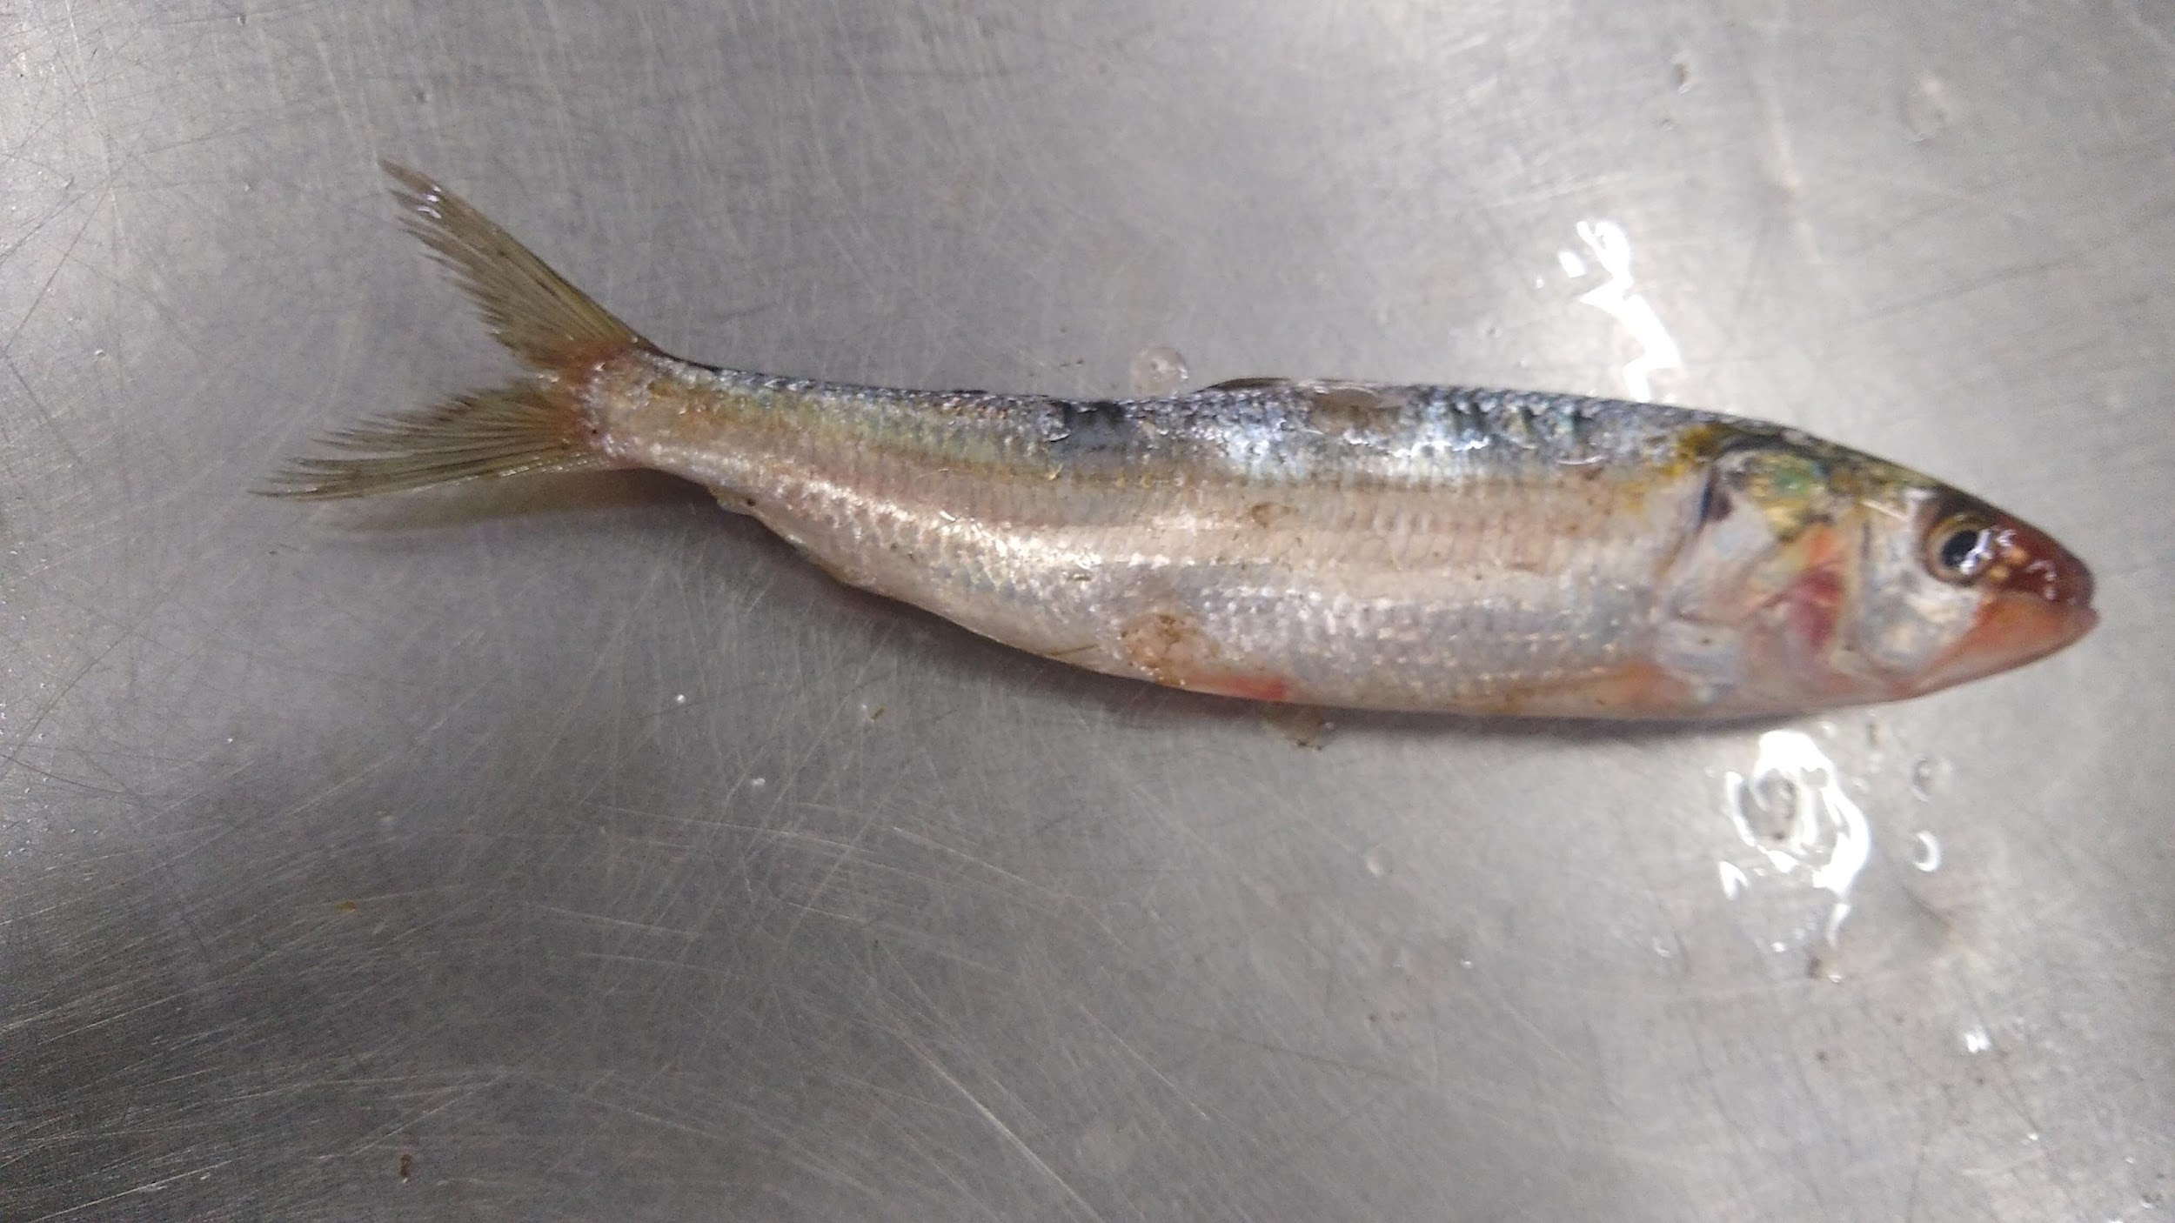
Cuts & damages model
[YOLO v8 Segmentation model]
Size based classification model
[Logistic regression model]

Input: Fish measurements like height, width, diagonal length, circumference, area
Softness based classification model
[Convolutional Neural
Network model]

Input: pre-processed image
Input image
Mobile app Results
No Cuts
Cuts
Size OK
Size NOT OK
Soft/NOT Soft

- What are the advantages of your invention over the prior solutions:
  - Multi-Criteria Analysis: Combines cuts and damages, size, and softness assessments, providing a comprehensive evaluation.
  - Automated and Objective: Reduces human error and variability, ensuring consistent results.
  - Scalability: Can be scaled to different types of fish and other seafood with minimal adjustments.
  - Real-Time Processing: Capable of providing immediate feedback, enhancing operational efficiency.

- Do you know of any competitor product or document, which is similar to your invention?

- When was your solution first conceptually or mentally complete:
  - The concept was first completed in April, 2024.

- What is the first tangible evidence of such completion?
  - The first tangible evidence was the implementation of a prototype model capable of classifying fish based on cuts and damages in April,2024.

- Has the invention been published or disclosed to any client, vendor, partner etc.:
- Yes/No: No
- If yes, when?: N/A
- If planned - when?: N/A
- Was there a nondisclosure agreement (NDA)?: N/A

- Please list down a few application areas in which this invention can be used:
- Fish and seafood processing plants
- Quality control in fisheries
- Retail seafood counters
- Online seafood marketplaces

- Field and Nature of Invention:
- Technical Field / Technology Area: Established/Evolving (Computer Vision, Machine Learning)
- Nature of Invention / Improvement: Incremental/Substantial
- Valid Life of this Technology: 3-5 years

- Please provide mandatory ratings on different aspects of this idea (5 being highest):
- Novelty rating of this idea: 4
- Inventiveness rating of this idea: 4
- Utility rating of the idea (1-3-5): 5
- Number of Unique Features / Embodiments: 3(YOLOv8 damage detection, size-based logistic regression, softness CNN model).

